Princess Sumaya University for Technology

# Embedded Systems

**Final Project Report**



|  |  |  |  |
| --- | --- | --- | --- |
| *Authors:* |  |  | *Supervisor:* |
| Ali Ziadeh  Talal Ateyyeh  Abdelhadi Shehadeh | 20210870  20210086  20180892 | Comp Eng.  NIS Eng.  Comp Eng. | Dr. Belal Sababha |

***Automated Pet Feeder***

*May 27, 2025*

***Abstract***

*This project presents the design and implementation of an automated pet feeder system using the PIC16F877A microcontroller. The system integrates multiple sensors including a touch sensor for user activation, an infrared sensor to monitor food storage levels, and an ultrasonic sensor to verify successful food dispensing. Actuators such as a servo motor and a DC motor manage the physical dispensing mechanism, while a buzzer and LEDs provide audible and visual feedback to the user. The embedded software employs timer-based sequencing and PWM control to ensure accurate operation independent of continuous user input. The ultrasonic sensor's feedback allows the system to detect and alert if food dispensing fails, improving reliability. This project demonstrates an effective application of embedded systems in automating routine pet care tasks, enhancing convenience and pet welfare.*

*.*

Table of Contents

Introduction 3

Objectives 3

Components 3

Hardware Design 4

* Circuit Schematic 4
* Prototype 5

Software Design 6

Conclusion 7

List of Figures

Figure 1: Electric Design 4

Figure 2: Exterior View 5

Figure 3: Software Design 6

# Introduction

Automated pet feeders are increasingly essential for ensuring timely and precise feeding of pets, especially for busy or frequently away pet owners. This project designs and implements an embedded pet feeder system based on the PIC16F877A microcontroller. The system integrates sensors and actuators including a touch sensor for user input, a servo motor for dispensing food, a DC motor for stirring or feeding mechanisms, and an ultrasonic sensor to verify successful food dispensing. The goal is to automate feeding while providing reliable feedback and control.

# Objectives

1- Develop an automated pet feeder system using PIC16F877A microcontroller.

2- Control a servo motor to dispense food portions.

3- Operate a DC motor and buzzer as feeding indicators.

4- Use a touch sensor to initiate feeding sequences.

5 -Integrate an ultrasonic sensor to detect whether food was properly dispensed.

6- Use an IR sensor to monitor food storage levels.

7- Provide LED indicators to signal system states (feeding, success, failure).

8- Implement timing and control logic to allow feeding sequences independent of continuous user input.

# Components

1. *Microcontroller* → **PIC16F877A**: Manages the entire system, processing input from sensors and controlling outputs.
2. *Input Devices* → **IR Sensor (Analog):** Monitors food storage levels**.**.

**Touch Sensor:** User input for triggering feeding sequences.

**Ultrasonic Sensor (HC-SR04)**: Measures distance to verify successful dispensing..

*3.Output Devices* → **Servo Motor**: Controls the dispensing mechanism opening and closing.

**DC Motor (H-bridge)**: Powers a fan when feeding.

**Buzzer**: Provides audible alerts during feeding.

**LED** : Signal feeding status and sensor feedback.

1. *Power Supply* →Regulated voltage source for the microcontroller from external battery and H-bridge**.**

# Hardware Design

## - Circuit Schematic

* + The schematic integrates all components, showing connections between the microcontroller, sensors, actuators, and power supply.
  + Key connections include:
  + RA0 is the IR sensor input (analog),
  + RA1 is the ultrasonic trigger (digital output),
  + RA2 is the ultrasonic echo (digital input),
  + RC6 is the touch sensor input (digital input),
  + RC1 controls the servo motor via CCP1 PWM output,
  + RC3 and RC4 are DC motor control outputs,
  + RC5 is the buzzer output,
  + and RB4 and RB5 are LEDs for status indication.

1. 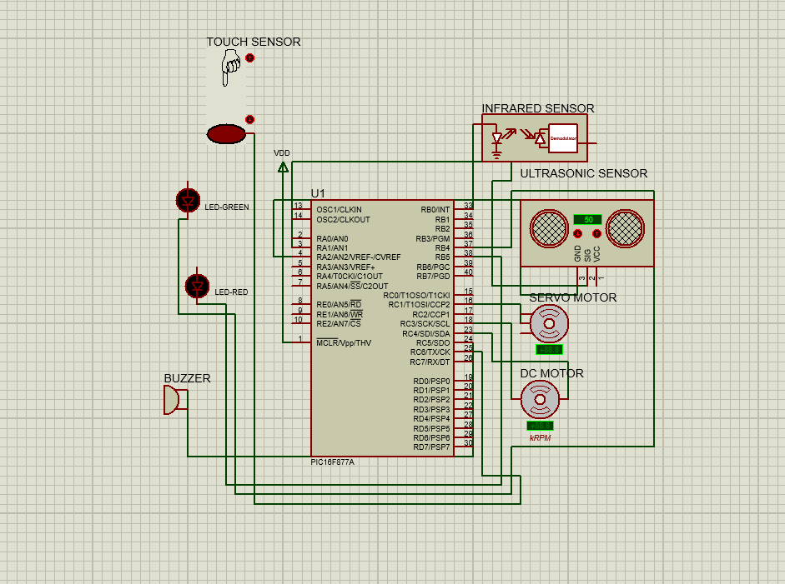

## - Prototype

*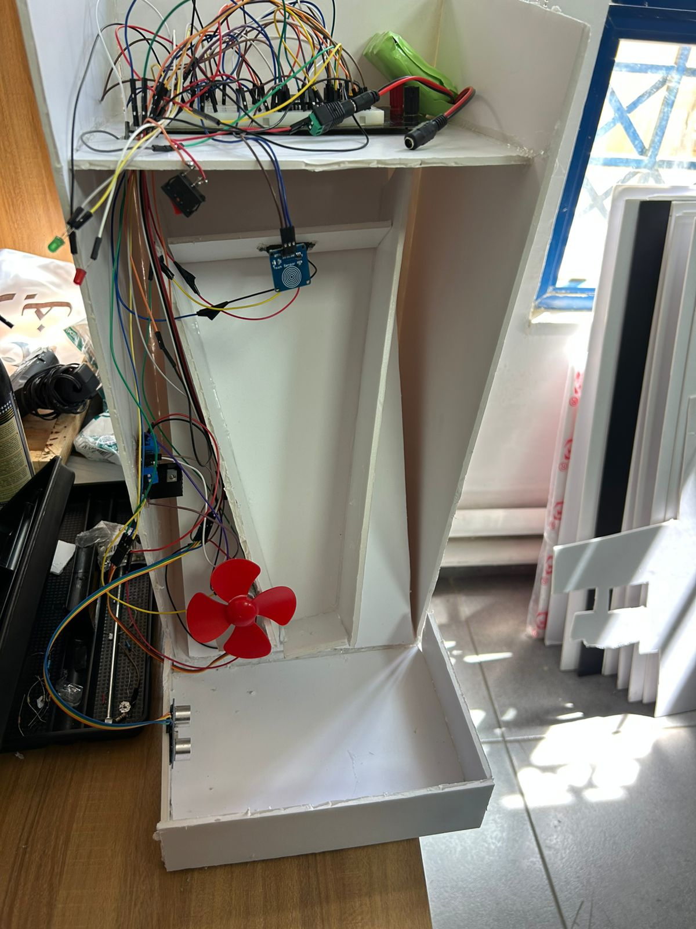Figure 2: Exterior View*

# Software Design

# 

*Figure 3: Software Design*

The embedded software consists of several key modules:

* **Sensor Reading:** ADC module reads the IR sensor to monitor food storage. The ultrasonic sensor is controlled by generating trigger pulses and measuring echo pulse width to determine distance.
* **Feeding Control:** A touch sensor input initiates the feeding sequence, which operates independently once triggered.
* **Actuator Control:** The servo motor is controlled via CCP1 PWM to open and close the dispenser. The DC motor and buzzer are turned on to signal feeding in progress.
* **Timing and Sequencing:** The feeding process uses timer interrupts and counters to run motors and servo for preset durations (e.g., 10 seconds for motor , buzzer and servo open).
* **Feedback and Status Indicators:** LEDs provide visual feedback on IR sensor status (food storage) and ultrasonic sensor results (successful dispensing).
* **Interrupt Service Routines:** Timer0 handles time counting for delays and feeding duration. CCP1 interrupt manages PWM for servo control.

The software is designed for non-blocking operation, allowing sensor monitoring and actuator control simultaneously.

# Conclusion

This project successfully developed a microcontroller-based automated pet feeder system integrating multiple sensors and actuators for reliable and autonomous feeding. The design leverages sensor feedback to verify dispensing success and provides clear user feedback through LEDs and audible alerts. The system demonstrates effective embedded system design principles and practical application for pet care automation.